NAME: MOBEEN AHSAN
ID: F2024266481
TEST MATRIX REPORT AND BASELINE
TEST MATRIX:
DEVICE 1 | PINGS TO | RESULT
STUDENT | STAFF | PASS
GUEST | STUDENT | FAIL
GUEST | ROUTER | PASS
GUEST | UBUNTU SERVER | PASS
STUDENT PC | EXTERNAL WAN (NAT) | PASS
GUEST PC | DNS SPOOFING | PASS

VERIFICATION SCREENSHOTS:
- STUDENT PC TO STAFF PC RESULT: PASS

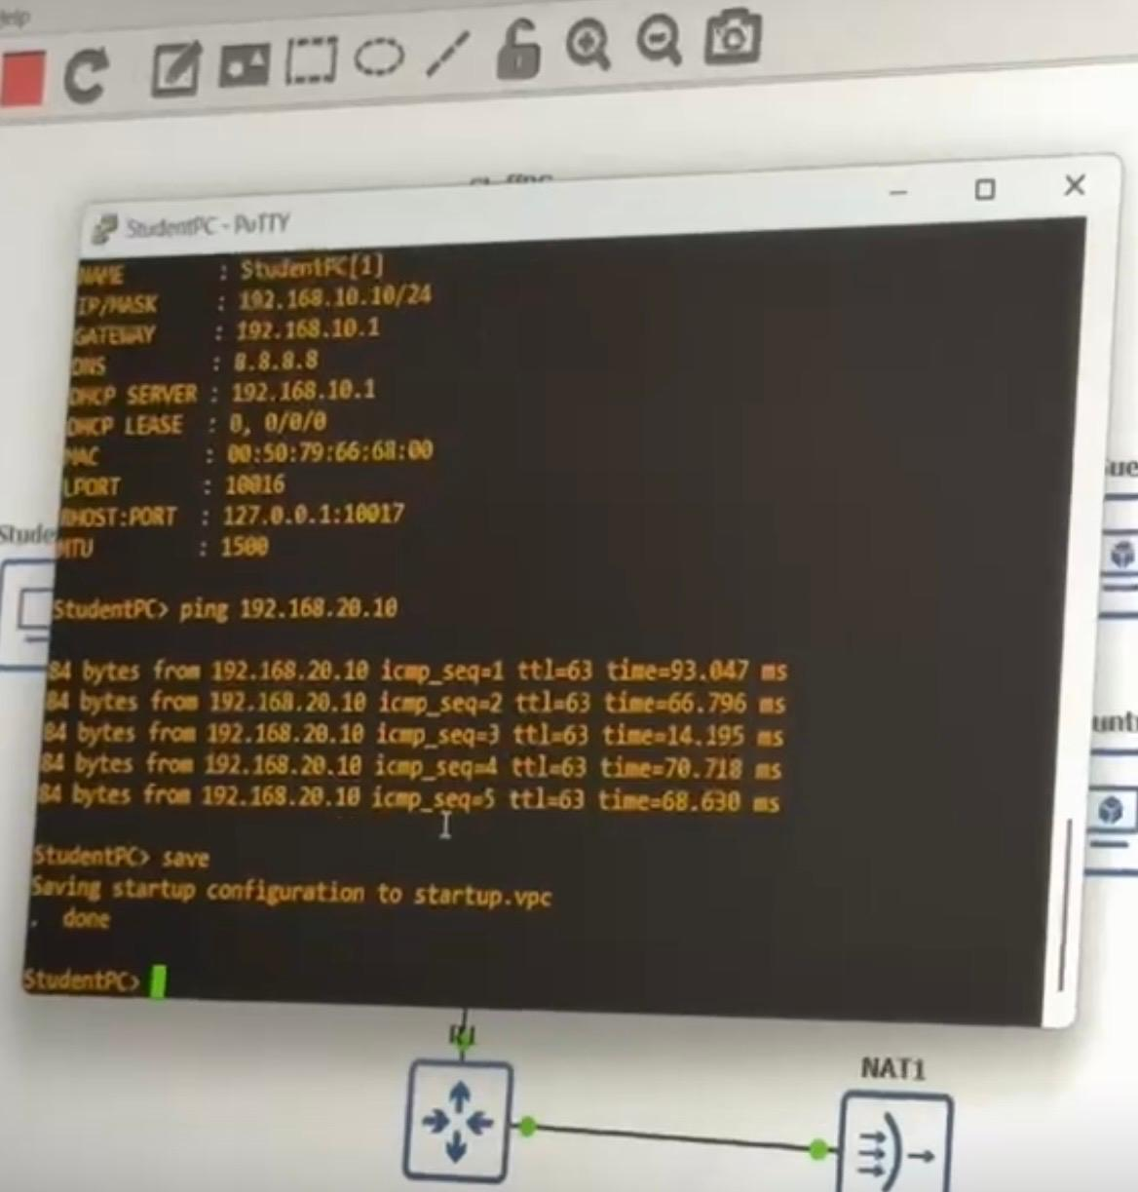

- GUEST PC TO STUDENT PC RESULT: FAIL

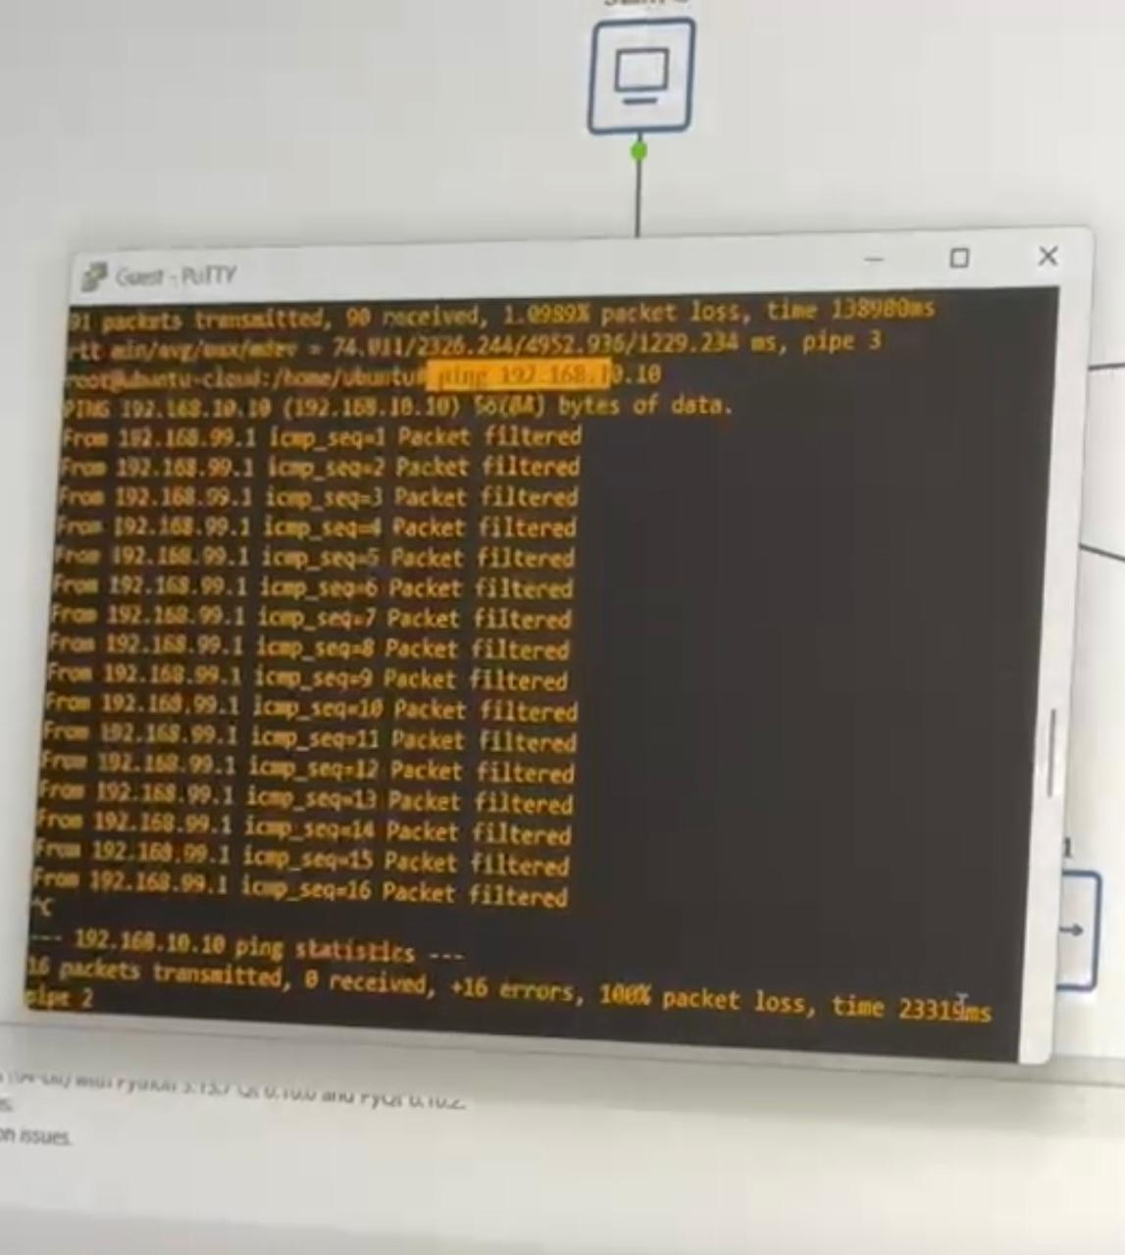

- GUEST TO ROUTER RESULT: PASS
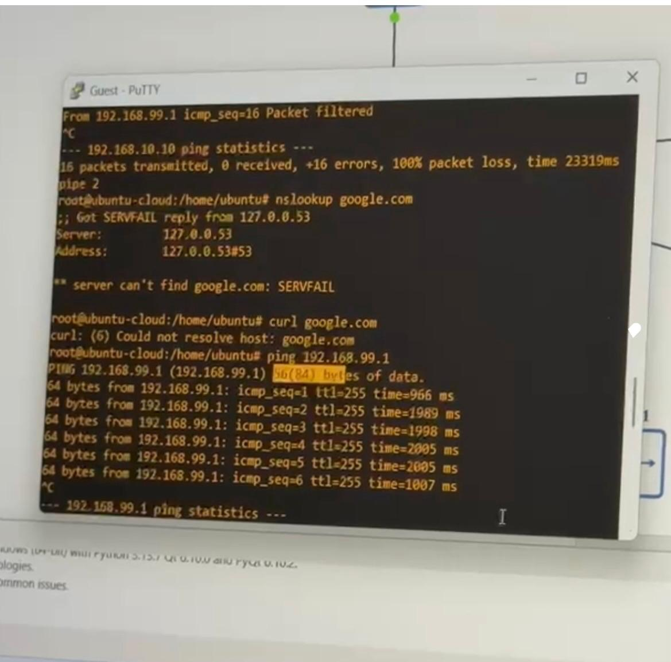

- GUEST TO UBUNTU SERVER
RESULT: PASS
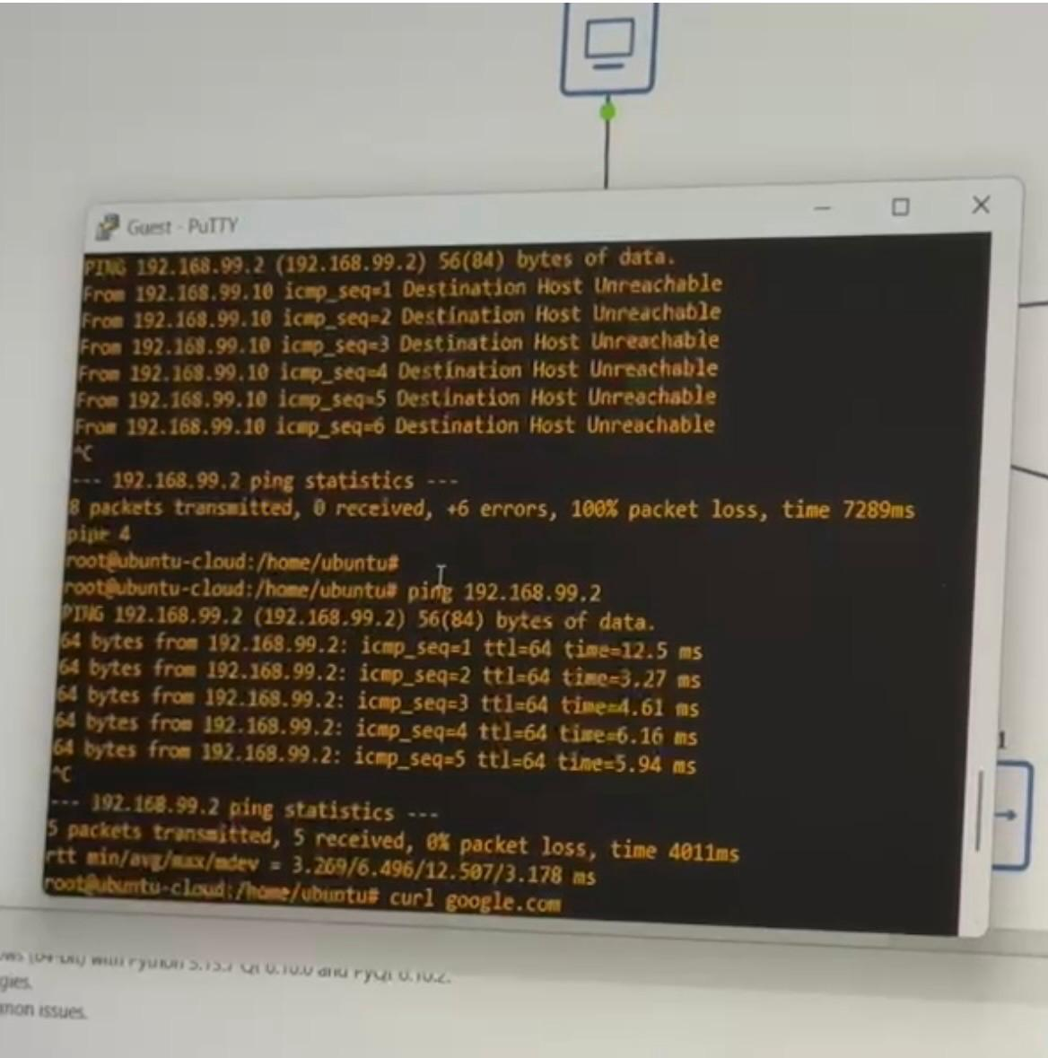

- GUEST DNS SPOOFING:

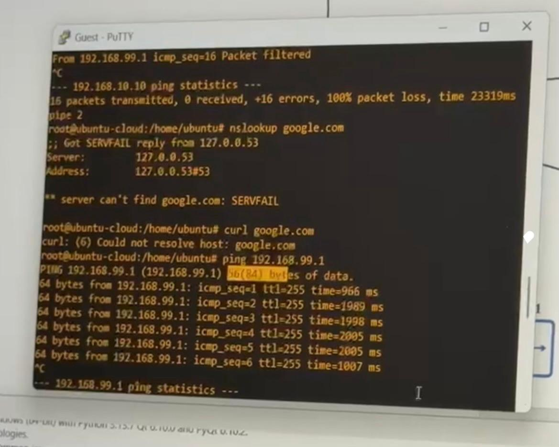

- INTERNET ACCESS VIA NAT:
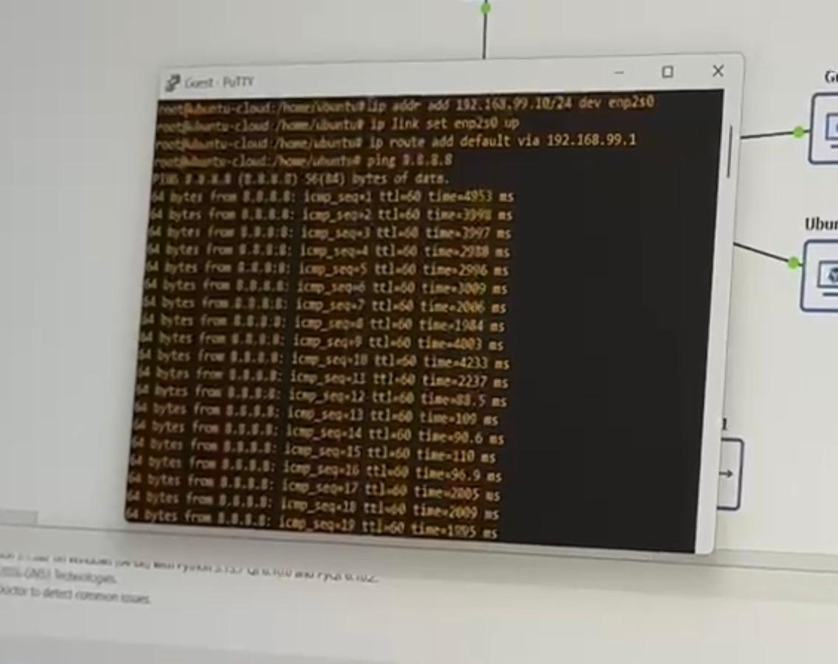

BASELINE PERFORMANCE REPORT:

TEST | RESULT
Student PC to Staff PC connectivity | successful
Guest isolation from Student VLAN | successful
Guest access to Router | successful
Guest access to Ubuntu | successful
Network stability | No packet loss observed
Student internet via NAT | successful
Guest DNS spoofing | successful

CONCLUSION:
The network was tested successfully. VLAN segmentation is working correctly. Guest users are isolated from Student and Staff networks while maintaining access to the router and Ubuntu server. All requirements specified in the project were met.

